# Лабораторна робота №2

**Тема: Буксування з одного компонента в інший**

**Хід роботи:**

# Задание 1.

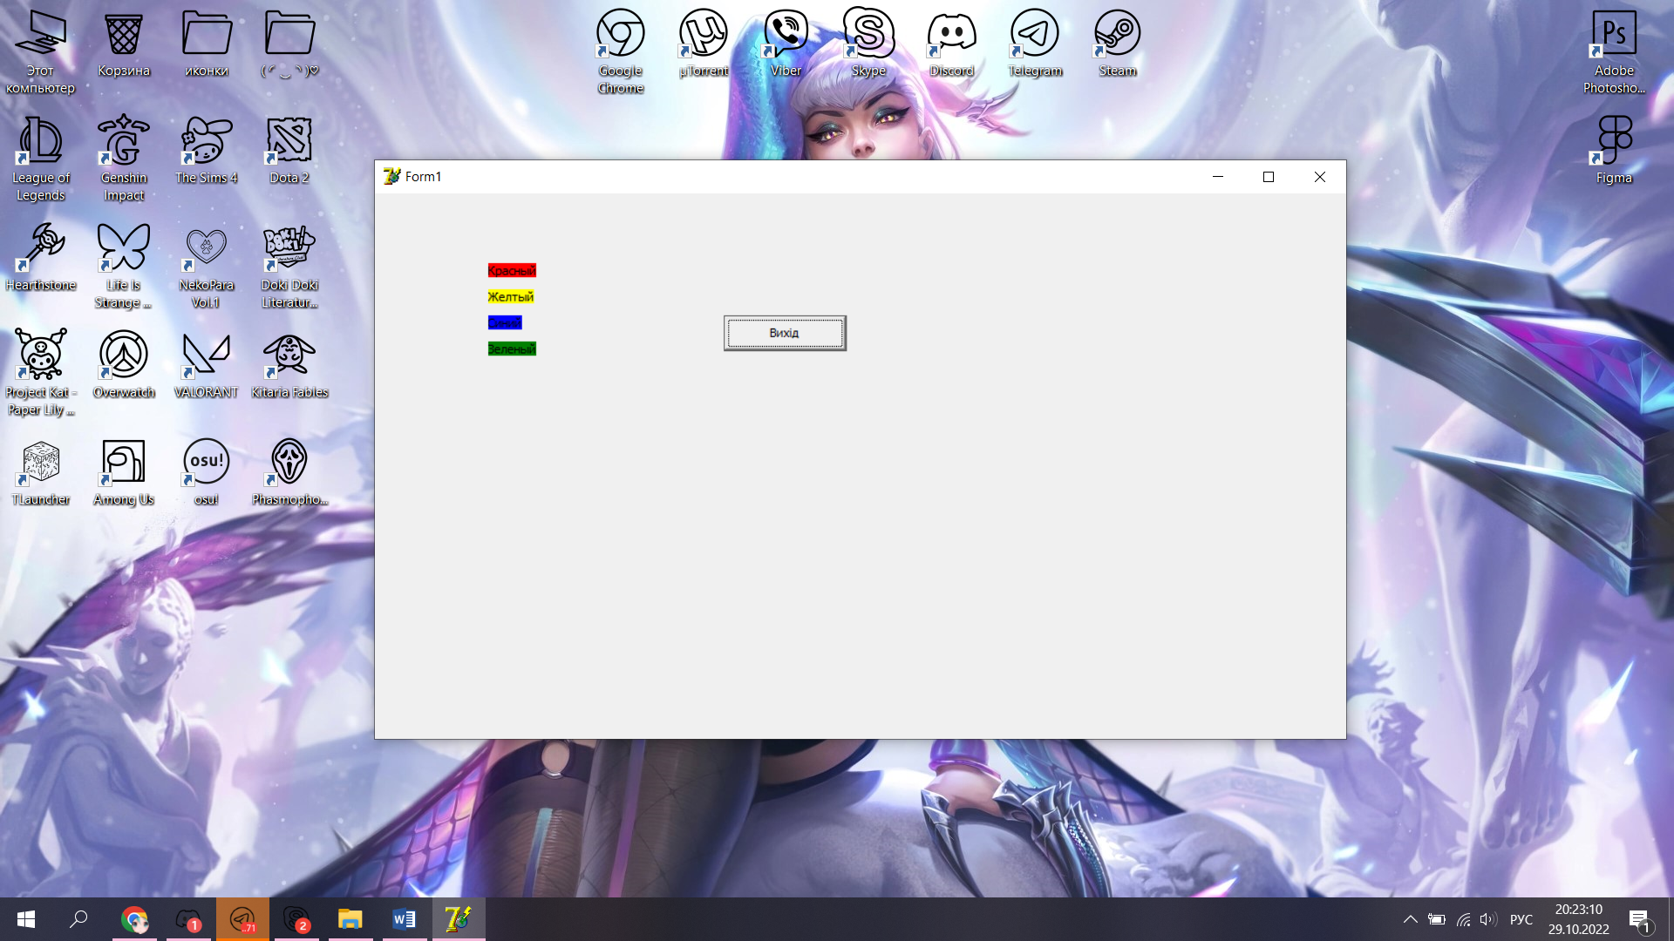

unit Unit1;

interface

uses

Windows, Messages, SysUtils, Variants, Classes, Graphics, Controls, Forms,

Dialogs, StdCtrls;

type

TForm1 = class(TForm)

lbl1: TLabel;

lbl2: TLabel;

lbl3: TLabel;

lbl4: TLabel;

btn1: TButton;

procedure lbl1DragOver(Sender, Source: TObject; X, Y: Integer;

State: TDragState; var Accept: Boolean);

procedure lbl2DragOver(Sender, Source: TObject; X, Y: Integer;

State: TDragState; var Accept: Boolean);

procedure lbl3DragOver(Sender, Source: TObject; X, Y: Integer;

State: TDragState; var Accept: Boolean);

procedure lbl4DragOver(Sender, Source: TObject; X, Y: Integer;

State: TDragState; var Accept: Boolean);

procedure lbl4DragDrop(Sender, Source: TObject; X, Y: Integer);

procedure lbl3DragDrop(Sender, Source: TObject; X, Y: Integer);

procedure lbl2DragDrop(Sender, Source: TObject; X, Y: Integer);

procedure lbl1DragDrop(Sender, Source: TObject; X, Y: Integer);

procedure btn1Click(Sender: TObject);

private

{ Private declarations }

public

{ Public declarations }

end;

var

Form1: TForm1;

implementation

{$R *.dfm}

procedure TForm1.lbl1DragOver(Sender, Source: TObject; X, Y: Integer;

State: TDragState; var Accept: Boolean);

begin

Accept:= Source is TLabel;

end;

procedure TForm1.lbl2DragOver(Sender, Source: TObject; X, Y: Integer;

State: TDragState; var Accept: Boolean);

begin

Accept:= Source is TLabel;

end;

procedure TForm1.lbl3DragOver(Sender, Source: TObject; X, Y: Integer;

State: TDragState; var Accept: Boolean);

begin

Accept:= Source is TLabel;

end;

procedure TForm1.lbl4DragOver(Sender, Source: TObject; X, Y: Integer;

State: TDragState; var Accept: Boolean);

begin

Accept:= Source is TLabel;

end;

procedure TForm1.lbl4DragDrop(Sender, Source: TObject; X, Y: Integer);

begin

lbl4.Color := (Source as TLabel). Color;

end;

procedure TForm1.lbl3DragDrop(Sender, Source: TObject; X, Y: Integer);

begin

lbl3.Color := (Source as TLabel). Color;

end;

procedure TForm1.lbl2DragDrop(Sender, Source: TObject; X, Y: Integer);

begin

lbl2.Color := (Source as TLabel). Color;

end;

procedure TForm1.lbl1DragDrop(Sender, Source: TObject; X, Y: Integer);

begin

lbl1.Color := (Source as TLabel). Color;

end;

procedure TForm1.btn1Click(Sender: TObject);

begin

Exit

end;

end.

**Задание 2**. Создать программу, выполняющую следующие действия:

1. После запуска программы отображаются: две строки для ввода текущих курсов для евро и доллара; строка для ввода денежной суммы в гривнах; две строки для вывода эквивалента в евро, долларах.

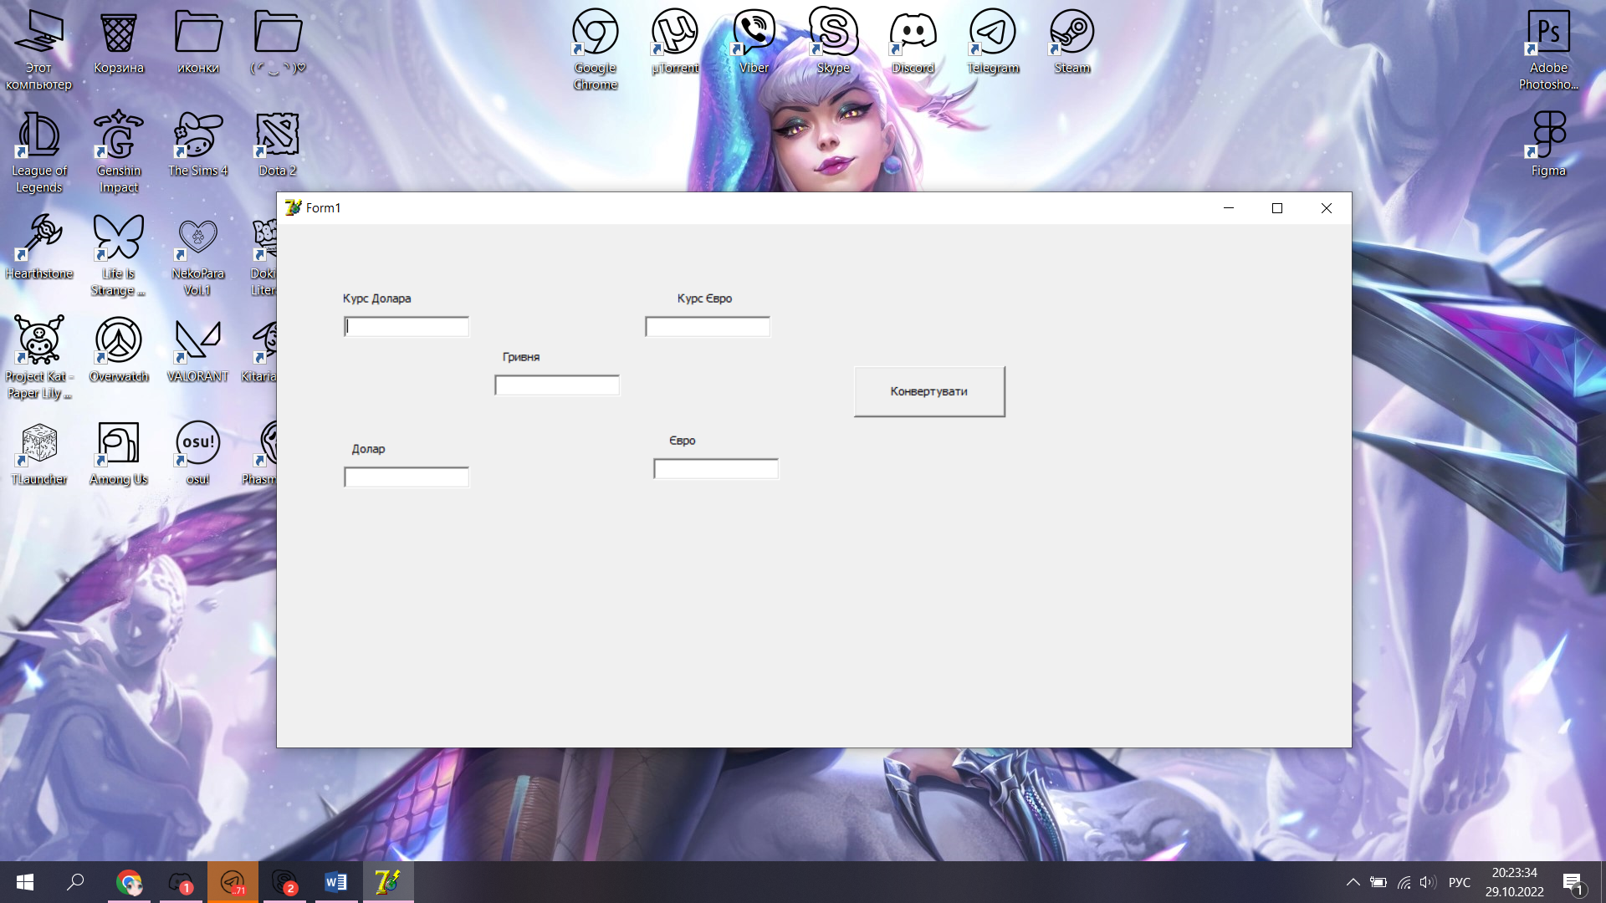

unit Unit1;

interface

uses

Windows, Messages, SysUtils, Variants, Classes, Graphics, Controls, Forms,

Dialogs, StdCtrls;

type

TForm1 = class(TForm)

Label1: TLabel;

Label2: TLabel;

Label3: TLabel;

Label4: TLabel;

Label5: TLabel;

Edit1: TEdit;

Edit2: TEdit;

Edit3: TEdit;

Edit4: TEdit;

Edit5: TEdit;

Button1: TButton;

procedure Button1Click(Sender: TObject);

private

{ Private declarations }

public

{ Public declarations }

end;

var

Form1: TForm1;

implementation

{$R *.dfm}

procedure TForm1.Button1Click(Sender: TObject);

var a: integer;

b: integer;

c: integer;

res1: integer;

res2: integer;

begin

a := StrToInt(Edit1.Text);

b := StrToInt(Edit2.Text);

c := StrToInt(Edit5.Text);

res1:=c div a;

res2:=c div b;

Edit3.Text:=IntToStr(res1);

Edit4.Text:=IntToStr(res2);

end;

end.